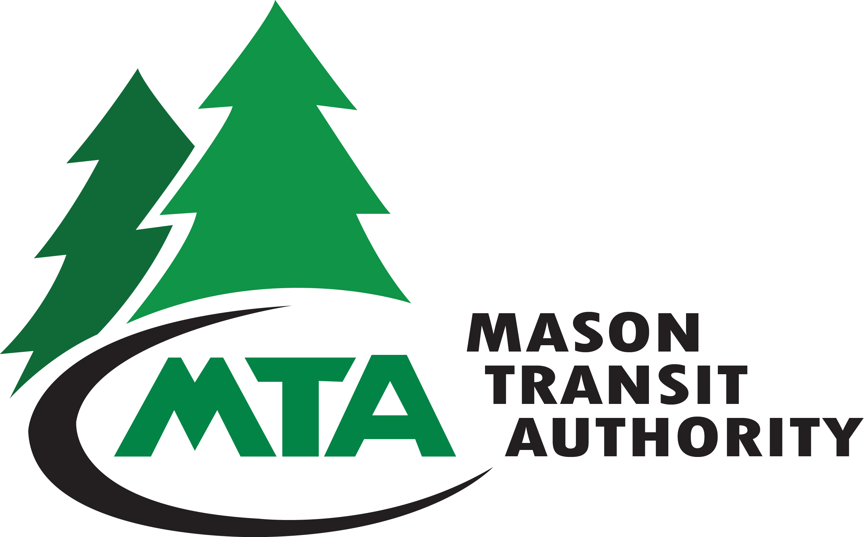 |  |  |  |  |  |  | APPLICATION FOR EMPLOYMENT  790 E Johns Prairie Road  Shelton, WA 98584  Phone: (360) 426-9434  FAX: (360) 426-9143  Website: www.masontransit.org |  |  |  |  |  |  |  |  |  |  |  |  |  |  |  |  | Date and Time Stamp
Position Desired:
PERSONAL
Last Name |  |  |  |  |  |  |  |  |  |  |  |  | First |  |  |  |  |  |  |  |  | Middle
Street Address |  |  |  |  |  |  |  |  |  |  |  |  |  |  |  |  |  |  |  |  |  | Home Phone
City |  |  |  |  |  |  |  |  |  | State |  |  |  |  |  | Zip Code |  |  |  |  |  | Cell Phone
Availability |  |  | Immediate |  |  |  |  |  |  |  |  |  |  |  | E-Mail address
 |  |  | Other (specify) |  |  |  |  |  |  |  |  |  |  |  | Will you work overtime if asked?  YES NO
Are you legally eligible for employment in the United States? YES NO
Type of work you will accept. |  |  |  |  |  |  |  |  | Full Time |  |  |  |  |  |  |  | Part Time |  |  |  | Seasonal |  |  |  |  |  | Temporary
Hours of work you will accept. |  |  |  |  |  |  |  |  | Day Shift |  |  |  |  |  |  |  | Swing Shift |  |  |  | Any Shift
Days of week you are willing to work. |  |  |  |  |  |  |  |  |  |  | MON TUE WED THU FRI SAT ANY DAY
EDUCATION
School |  |  |  | Name & Location of School |  |  |  |  |  |  |  |  |  | Course of study completed |  |  |  |  |  | Dates attended |  |  | Did you graduate |  |  |  |  | Degree or diploma
High School |  |  |  |  |  |  |  |  |  |  |  |  |  |  |  |  |  |  |  |  |  |  | YES  N0
Business/Trade/ Technical |  |  |  |  |  |  |  |  |  |  |  |  |  |  |  |  |  |  |  |  |  |  | YES  NO
College |  |  |  |  |  |  |  |  |  |  |  |  |  |  |  |  |  |  |  |  |  |  | YES  NO
Languages Read, Written or Spoken Fluently, Other Than English:
Except for a lay off due to lack of work, have you ever been discharged (fired) or resigned (quit) in lieu of discharge?
YES NO
Have you been employed at Mason Transit Authority in the past? YES NO

Name: |  |  |  | Position Desired:
EMPLOYMENT |  | Beginning with your present or most recent employment, list your work/experience for the past 10 years, accounting for gaps in employment. Use additional paper if necessary.
[1] Company Name |  |  |  |  | Telephone
Address |  |  |  |  | Employed (state month & year)
 |  |  |  |  | From |  | To
Name of Supervisor |  |  |  |  | Weekly pay
Reason for Leaving/Change |  |  |  |  | Start |  | Last
State Job Title and Briefly Describe Your Work

[2] Company Name |  |  |  |  | Telephone
Address |  |  |  |  | Employed (state month & year)
 |  |  |  |  | From |  | To
Name of Supervisor |  |  |  |  | Weekly pay
Reason for Leaving/Change |  |  |  |  | Start |  | Last
State Job Title and Briefly Describe Your Work

[3] Company Name |  |  |  |  | Telephone
Address |  |  |  |  | Employed (state month & year)
 |  |  |  |  | From |  | To
Name of Supervisor |  |  |  |  | Weekly pay
Reason for Leaving/Change |  |  |  |  | Start |  | Last
State Job Title and Briefly Describe Your Work

[4] Company Name |  |  |  |  | Telephone
Address |  |  |  |  | Employed (state month & year)
 |  |  |  |  | From |  | To
Name of Supervisor |  |  |  |  | Weekly pay
Reason for Leaving/Change |  |  |  |  | Start |  | Last
State Job Title and Briefly Describe Your Work

Name: |  |  |  |  |  |  |  | Position Desired:
MILITARY
Have you served in the U.S. Armed Forces? YES NO |  |  |  |  |  |  |  |  |  |  | If “YES”, in what branch?
Describe any training received relevant to the position for which you are applying.
OTHER SKILLS & QUALIFICATIONS
What office machines do you operate? |  |  |  |  |  |  |  |  |  |  |  |  | If you keyboard, what are your words per minute?
Computer software?
List any special technical or machine operations skills that you have gained from employment, training, experience as a volunteer, or through other means?
PROFESSIONAL LICENSES OR CERTIFICATES
License or Certificate |  |  |  |  | Serial Number |  |  |  | Date Issued |  |  |  |  |  | Expiration Date
DRIVING INFORMATION – NOTE: If applying for a driver position, please include a driver’s
abstract, dated no more than one month prior to application submission date.
If the position requires the operation of a motor vehicle, please complete the following:
Do you possess a valid driver’s license? YES NO
STATE: |  |  |  | LICENSE NUMBER: |  |  |  |  |  |  |  | EXPIRATION DATE:
CLASS: |  |  |  | ENDORSEMENTS:
Have you had a driver’s license in another state within the past three (3) years? YES NO
If yes: STATE: |  |  |  |  |  | LICENSE NUMBER:
Has your license ever been restricted, suspended or revoked? YES NO
If “YES” please explain:
Have you had any moving violations within the past ten (10) years? YES NO

Name: |  |  |  |  | Position Desired:
CONVICTIONS
Have you been convicted of a crime in the past ten (10) years, excluding misdemeanors and summary offenses, which has not been annulled, expunged or sealed by the court? YES NO
NOTE: A conviction record will not automatically disqualify you for employment unless we determine such record could reasonably affect your fitness for the job for which you are applying.
If “YES” describe in full:
RELATIVES WORKING FOR MASON TRANSIT AUTHORITY
Are you related to any current Mason Transit Authority employee? If yes,
Name: Relationship:
PRACTICAL SKILLS TEST
A practical skills test that will test applicants on the skills necessary to perform the duties of the position you are applying for may be given to each applicant. If you require any form of accommodation during the testing process, please indicate below the nature of the accommodation requested.

AGREEMENT, CERTIFICATION & AUTHORIZATION (Please Read Carefully)
It is the policy of Mason Transit Authority, as part of the selection process, to contact former employers for reference information. By signature below, I authorize Mason Transit Authority to contact my former employers.

I authorize Mason Transit Authority to conduct a background check and if I request, provide me with the name of the agency so I may obtain from them the nature and substance of information contained in the report.

I acknowledge that employment for a safety-sensitive position is contingent upon successful completion of a physical examination. In addition, I understand that my employment is contingent upon successfully completing a USDOT drug test as required by 49 CFR Part 655 and, if hired, I understand that a condition of my employment will be compliance to the Agency’s Drug and Alcohol Policy, including submitting to drug and alcohol tests as described in the policy.

I certify that the information shown on this application is true and correct to the best of my knowledge. I further agree that falsifying or withholding of pertinent information given in my application or interview(s) will be grounds for non-consideration, or if employed, will be cause for dismissal. Failure to sign and date this form will also be grounds for non-consideration.
Signature of Applicant |  |  |  |  |  |  | Date
You may contact my current employer: YES NO CONTACT ME FIRST

ALL APPLICATIONS MUST BE SIGNED AND DATED IN ORDER TO BE ACCEPTED FOR CONSIDERATION.
MASON TRANSIT AUTHORITY IS AN EQUAL OPPORTUNITY EMPLOYER.
Employees must abide by Mason Transit Authority’s drug and alcohol policy as a condition of employment.

I learned of this job opening through (check all that apply)
Friend or relative |  | Newspaper (name) |  | Transit employee (name) |  | Job posting (where) |  | Website |  |  | Other

 |  |  |  |  | AFFIRMATIVE ACTION FORM
CONFIDENTIAL
The policy of Mason Transit Authority is to ensure equal opportunity in employment and promotion. This policy will be administered without regard to race, religion, color, national origin, marital status, gender, age or the presence of disabilities.

The information requested below will be used for statistical purposes only, as required by the Equal Employment Opportunity Commission (EEOC). This is voluntary information and is on a separate form and will not be filed with your job application. If you have questions please contact the Human Resources Department.
Name |  |  |  |  |  |  |  | Birthdate |  |  | Gender | Female  Male
Street Address |  |  | City |  |  | State | Zip Code | Telephone Number
Position Applied For
Ethnic Background With which ethnic group do you most identify (Check one)
AMERICAN INDIAN OR ALASKAN NATIVE – A person with origins in any of the original peoples of North America who maintains identifiable tribal affiliations through membership and participation or community identification.
ASIAN – Includes origins in the Far East, Southeast Asia, Pacific Islands, Indian Subcontinent (China, Japan, Korea, Philippines, Samoa, Vietnam, India, Pakistan).
BLACK – Includes origins in any black racial group.
HISPANIC – Includes origins in Mexico, Puerto Rico, Cuba, Central or South America.
CAUCASIAN – Includes origins in Europe, North Africa, Middle East; not Hispanic or East Indian.
MIXED RACE
Are you a veteran? |  |  |  | Are you a disabled veteran? |  |  |  |  | Are you a Vietnam era veteran?
Yes No  Date of Discharge: |  |  |  | Yes No |  |  |  |  | Yes No
Do you consider yourself to be disabled (physically, mentally, or sensory)?
Yes No

Do you require special accommodation to participate in the application or examination process?
Yes No

AN EQUAL OPPORTUNITY EMPLOYER

